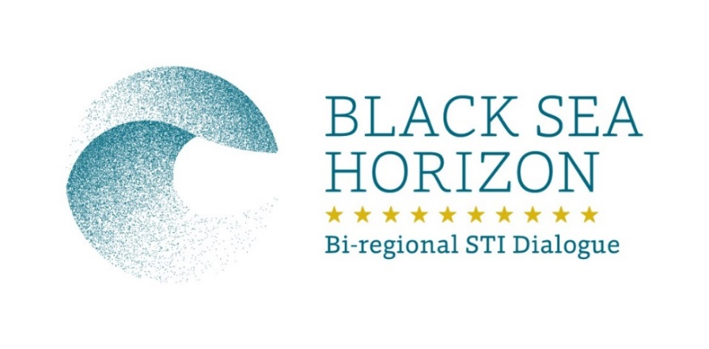

APPLICATION FORM

General Information
Family name:
First name:
Sex: | female male
Date of birth (dd/mm/yy):
Place of birth:
Nationality(ies):
Telephone:
Fax:
E-mail:
Address for correspondence:

Current Professional Affiliation
Institution /Company:
Department / Faculty:
Address of the institution:
Country:
Institution’s website:

Research activity
Keywords of your research topics
Title of your PhD dissertation
Please list your most important publications (approximately 5) including if possible the D.O.I.
Total number of citations
Patent (if any)

Languages
Mother language:
 | Understanding | Speaking | Writing
English
Other languages
(specify)

Use the Common European Framework to describe your skills: A1=beginner, A2=elementary / B1=threshold, B2=intermediate / C1=effective operational proficiency, C2=advanced

Projects and international cooperation activities
Please list the relevant research projects you have participated in. Please duplicate the table if necessary.

Project title
Thematic area
Funded by
Partners involved
Role of researcher in the project

Expected outcome:
Please provide a short explanation about the following issues:
How is your research field connected to the topic of the chosen Brokerage Event?

Why do you want to participate in the Brokerage Event? What kind of outcome/networking possibilities are you expecting? Please be as concrete as possible. How many meetings with organisations do you plan and what will be the concrete result (agreements, follow-up)

What kind of activities are you planning to carry out during the event? (Presenting your field of research/project ideas/a poster, participation in bilateral talks/matchmaking etc.) In case of presentation or participation in poster session, please include the abstract too (half page max.).

Event Details
Event name and dates:
Estimated costs: Tickets
Accommodation
Total Estimated Costs

Please specify at least one open or expected to be open call from H2020 following the H2020 Work Programmes, which is the focus of your field of research
-
-
-

Additional documentation required

- CV with full list of publications, patents, conference presentations, international experience
- scanned version of English language certificate (at least intermediate)

………………………………………….

Date and Full name (of the candidate)
To be submitted by e-mail to the Local Partner:
Name: Tigran Arzumanyan
Contact email: tarznip@sci.am
Local Partner: National Academy of Sciences of RA
Task Leader: RCISD
blacksea@rcisd.eu

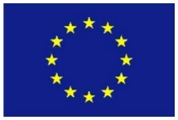
The project BLACK SEA HORIZON has received funding from European Union’s Horizon 2020 research and innovation programme under grant agreement No 645785 [H2020-INT-INCO-2014].

